height 4pt
Indian Institute of Technology Kanpur
CS771: Introduction to Machine Learning
Assignment 1 Report
Antriksh Singhal (240150)
Anushka Shrivastava (240164)
Arshdeep Singh (240197)
Kushal Jain (240587)
Saket Pratap Singh (240909)
Shruti Sharma (241006)
June 12, 2026

height 1pt

1 Problem 1. Mathematical Derivation for Prediction
To express the Hamming PUF operations as a linear model, we map the binary challenge bits $c∈\{0,1\}^{32}$ and secret bits $s∈\{0,1\}^{32}$ into the bipolar domain $\{−1,1\}$. Let
$$x_{i}=1−2c_{i}$$
and
$$y_{i}=1−2s_{i}.$$
In this domain, the XOR operation $m_{i}=c_{i}⊕s_{i}$ can be expressed as algebraic multiplication:
$$1−2m_{i}=x_{i}y_{i}$$
which implies
$$m_{i}=\frac{1−x_{i}y_{i}}{2}.$$
We can now substitute this into the equations for the partial Hamming weights. For the even locations:
$$h_{e}=\sum_{i=0}^{15}{m_{2i}}=\sum_{i=0}^{15}{\frac{1−x_{2i}y_{2i}}{2}}=8−\frac{1}{2}\sum_{i=0}^{15}{x_{2i}}y_{2i}.$$
For the odd locations:
$$h_{o}=\sum_{j=0}^{15}{m_{2j+1}}=\sum_{j=0}^{15}{\frac{1−x_{2j+1}y_{2j+1}}{2}}=8−\frac{1}{2}\sum_{j=0}^{15}{x_{2j+1}}y_{2j+1}.$$
The PUF response is 1 if $h_{e}h_{o}≥t$. Expanding the product $h_{e}h_{o}$:
$$h_{e}h_{o}=\left(8−\frac{1}{2}\sum_{i=0}^{15}{x_{2i}}y_{2i}\right)\left(8−\frac{1}{2}\sum_{j=0}^{15}{x_{2j+1}}y_{2j+1}\right).$$
Thus,
$$h_{e}h_{o}=64−4\sum_{i=0}^{15}{x_{2i}}y_{2i}−4\sum_{j=0}^{15}{x_{2j+1}}y_{2j+1}+\frac{1}{4}\sum_{i=0}^{15}{\sum_{j=0}^{15}{(}}x_{2i}x_{2j+1})(y_{2i}y_{2j+1}).$$
The inequality condition for the response being 1 is therefore
$$64−4\sum_{i=0}^{15}{x_{2i}}y_{2i}−4\sum_{j=0}^{15}{x_{2j+1}}y_{2j+1}+\frac{1}{4}\sum_{i=0}^{15}{\sum_{j=0}^{15}{(}}x_{2i}x_{2j+1})(y_{2i}y_{2j+1})−t≥0.$$
This is a linear inequality of the form $w^{⊤}ϕ(c)+b≥0$. We can separate the terms that depend purely on the challenge $c$ (the features $ϕ(c)$) from the terms that depend on the secret $s$ and threshold $t$ (the weights $w$ and bias $b$).
Given a challenge $c$, first compute $x_{k}=1−2c_{k}$. The feature vector $ϕ(c)$ consists of the following components:
- $x_{2i}$ for $i∈\{0,…,15\}$ (the even bits)
- $x_{2j+1}$ for $j∈\{0,…,15\}$ (the odd bits)
- $x_{2i}x_{2j+1}$ for $i,j∈\{0,…,15\}$ (all pairwise products of even and odd bits)
The corresponding weight vector $w$ consists of:
- $−4y_{2i}$ corresponding to the even-bit features,
- $−4y_{2j+1}$ corresponding to the odd-bit features,
- $\frac{1}{4}y_{2i}y_{2j+1}$ corresponding to the pairwise-product features.
The bias term is $b=64−t$. Because the inequality exactly matches $w^{⊤}ϕ(c)+b≥0$, the response can be perfectly modeled as:
$$r(c)=\frac{1+\text{sign}(w^{⊤}ϕ(c)+b)}{2}.$$

2 Problem 2. Dimensionality Calculations
The dimensionality $D$ of the linear model is determined by the number of unique elements in the derived feature map $ϕ(c)$. Breaking down the elements of $ϕ(c)$:
- Even terms: There are 16 even-indexed bits $(x_{0},x_{2},…,x_{30})$, contributing 16 dimensions.
- Odd terms: There are 16 odd-indexed bits $(x_{1},x_{3},…,x_{31})$, contributing 16 dimensions.
- Cross-product terms: We take the product of every even bit with every odd bit, $x_{2i}x_{2j+1}$. Since there are 16 even bits and 16 odd bits, there are $16×16=256$ unique cross terms, contributing 256 dimensions.
Summing these contributions,
$$D=16+16+256=288.$$
Therefore, a linear model requires exactly 288 dimensions to perfectly predict the responses for a 32-bit Hamming PUF.

3 Problem 4. Experimental outcomes and hyperparameter analysis
We evaluated LinearSVC and LogisticRegression to break the Hamming PUF using the 288-dimensional embedding. Results are reported on the public dataset.

3.1 Impact of loss function (linearsvc)
We compared Hinge and Squared Hinge loss. As shown in Table 1, Squared Hinge loss is significantly more computationally efficient for this dataset while maintaining similar accuracy.
Comparison of loss functions in LinearSVC
Loss | Train Acc (%) | Test Acc (%) | Time (s)
Hinge | 99.88 | 99.88 | 1.224
Squared Hinge | 99.92 | 99.88 | 0.287

3.2 Impact of regularization strength ($C$)
High values of $C$ (low regularization) allow for higher accuracy but may increase training time slightly. Low $C$ leads to underfitting, especially in Logistic Regression.
Effect of $C$ on Accuracy
 | LinearSVC |  | LogisticRegression
2-3 (l)4-5 $C$ | Train Acc | Test Acc | Train Acc | Test Acc
0.001 | 98.55% | 96.80% | 95.73% | 93.56%
0.1 | 99.93% | 99.88% | 99.23% | 98.16%
10.0 | 99.97% | 99.88% | 99.25% | 98.12%

3.3 Impact of tolerance ($tol$)
Tolerance ($tol$) acts as a stopping criterion. A high tolerance (${10}^{−1}$) causes Logistic Regression to stop prematurely, resulting in random-chance accuracy ($≈48\%$), whereas LinearSVC remains robust. Optimal convergence for both was observed around ${10}^{−3}$.

3.4 Impact of penalty (l1 vs l2)
The $L2$ penalty was significantly faster across both models. For LinearSVC, $L1$ took 11.026s compared to 0.234s for $L2$. Similarly, LogisticRegression was faster with $L2$ (0.126s) than $L1$ (2.407s).

4 Problem 5. Impact of training set size on accuracy
To determine the minimum number of Challenge-Response Pairs (CRPs) required to break the Hamming PUF effectively, we conducted experiments with varying training set sizes ranging from 100 to 7500 points. For each size, we performed 10 independent trials, selecting training points randomly without replacement from the original set while keeping the test set fixed.

4.1 Performance across dataset sizes
The experimental results indicate a logarithmic-like growth in accuracy relative to the number of training points. While the full dataset contains 7500 points, near-perfect accuracy is achieved much earlier.
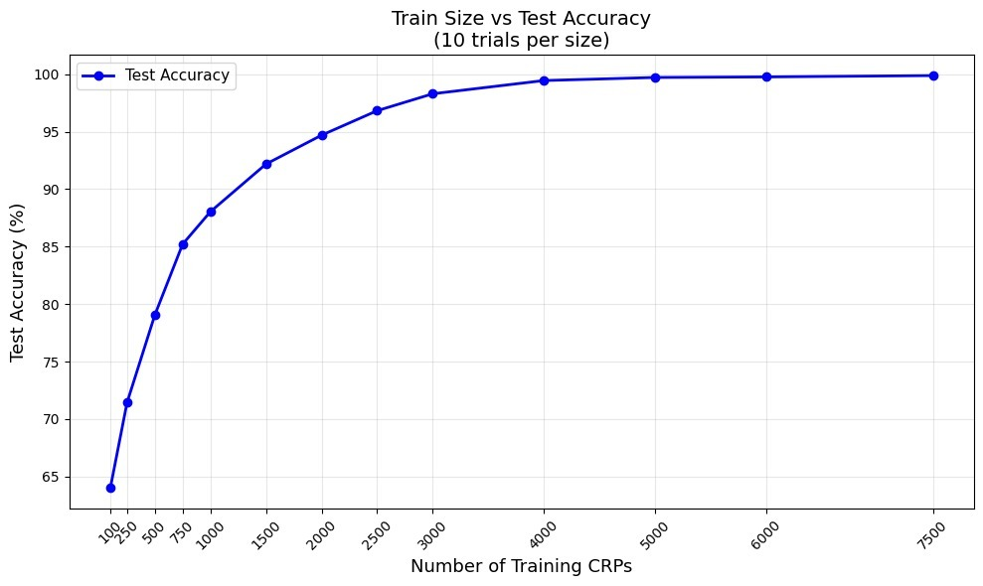
training set size vs test accuracy over 10 trials per size.

4.2 Minimum crps for accuracy thresholds
Based on our empirical analysis, the following minimum number of CRPs are required to reach specific accuracy milestones:
- 95% Accuracy: Approximately 2100 CRPs (achieved 95.30% in trials).
- 97% Accuracy: Approximately 2600 CRPs (achieved 97.08% in trials).
- 99% Accuracy: Approximately 3500 CRPs (achieved 99.18% in trials).
Beyond 3500 points, the accuracy gains become marginal, with the model saturating near 99.8% at the full 7500 points. This suggests that the 288-dimensional linear model is highly sample-efficient for this specific PUF architecture.

4.3 Training time observations
As expected, training time scales linearly with the number of training points. For $N=100$, training took approximately 0.06s, whereas for $N=3800$, it increased to 1.26s. Even at higher sample sizes, the LinearSVC model remains computationally viable for real-time PUF modeling.

